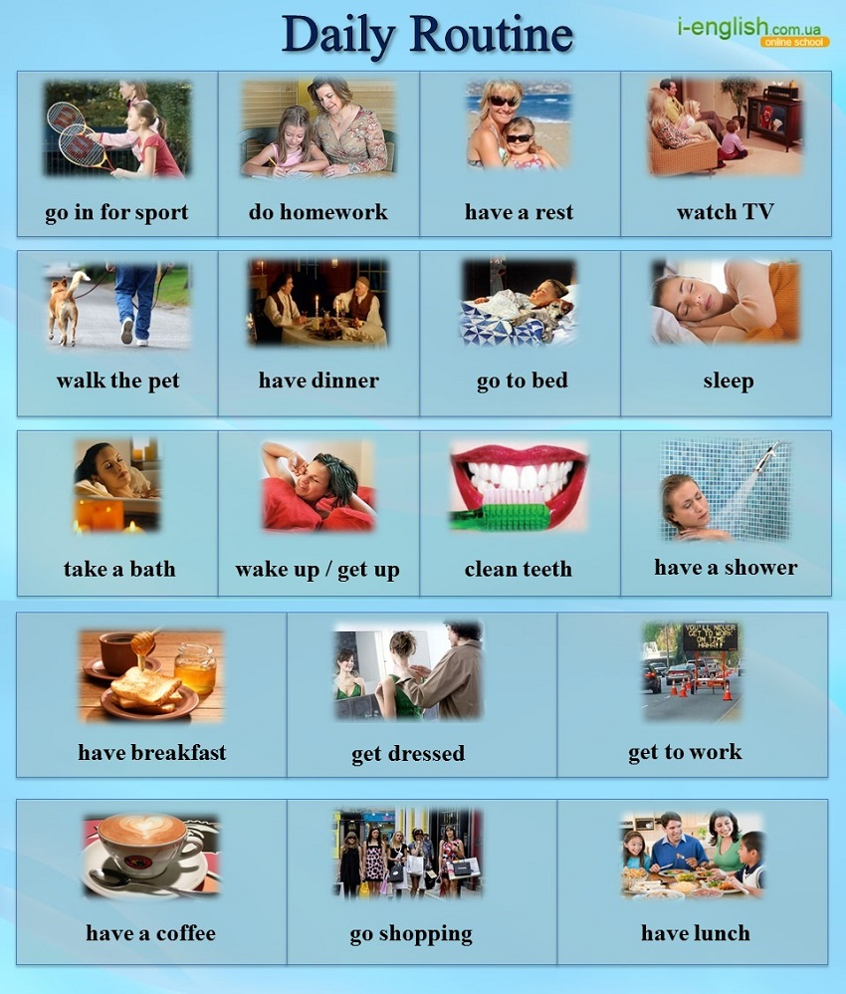

Расставь правильно слова в предложения
- Oh, that little green budgie! It ____ me up every early morning.
- We have a tradition since our University years: every Sunday we go ___ and buy food for
poor people from our local Charity Hospital.
- If you want to have healthy white smile you have to ___ your teeth twice a day and visit your dentist
once a year. But who visits them so often?
- My day was so stressful. I`m waiting forward to a hot foamy bubbles. I can relax only when
I ______.
- I even haven`t got a TV set! So I don`t ____, indeed!
- They presented me a dog for my birthday yesterday. But I have no time to ____!
I`m 50 –years old successful businessman. Why didn`t they ask me first?
- - Mum, can I watch my lovely cartoon? – Do your ____ first and then you can watch it!

Ответь на вопросы по теме Daily routine
- Do you have breakfast every morning or you have no time for it?
- How do you get to your work (study): by bus, by tram, in the car, on foot?
- Do you usually have dinner with your family? Who cooks meals? Who washes dishes?
- If you drink coffee, do you add milk?
- Are you a morning person? Do you like waking up early?

